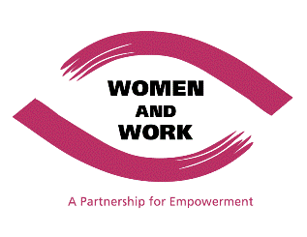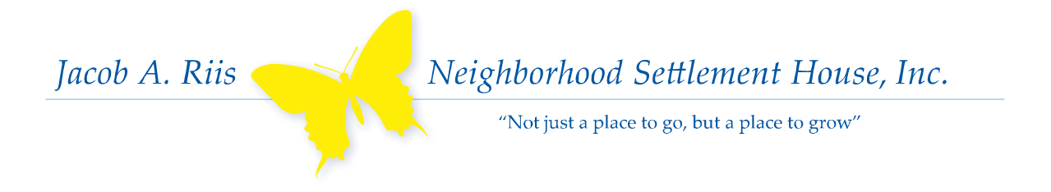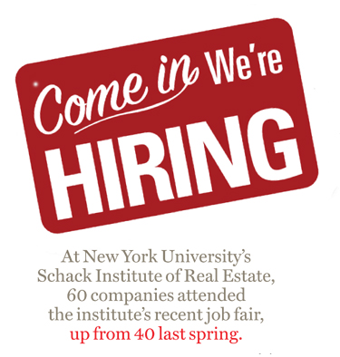

Professional Training

Entrepreneur Space

Job Openings

Jacob A. Riis Neighborhood Settlement House is proud to present to you the October issue of our Job Access Newsletter. This Newsletter is part of our ongoing efforts to expand and strengthen our adult programing services. The Newsletter will serve as an informative vehicle to connect adults in the community to job opportunities and recognized job training programs. We aim to publish an issue each month and will strive to keep you connected and well-informed. We encourage you to contact Gary Anthony, Executive Assistant, at ganthony@risssettlement.org or (718) 784-7447 ext.120 in case you have any questions or seek further information on the opportunities presented below.

## **Connecting You with Job Opportunities and Training Programs**

**T-Mobile:** Retail Sales

Associate (Bilingual)

**Responsibilities:**

* Deliver a strong, genuine customer experience
* Make wireless terms, products, and services seem simple and understandable
* Maintain a neat, clean, organized store environment
* Make the most effective use of store displays and interactive devices
* Provide Store Management with feedback and solutions to improve customer service and sales results

**Qualifications:**

* High School Diploma
* Basic Computer Skills
* Excellent written and verbal communication skills
* Prior customer service and sales experience
* Must be fluent in English and Spanish

**Location:** *7th Avenue & 48th Street*

**To Apply: Visit** www.jobs.tmobile.com

**Who We Are:** Women and Work (W&W) is a FREE job-skills and life-management training program for women offered through Queens College, CUNY.

**What We Do:**

We help members of the most underserved populations (immigrants, domestic violence victims, displaced homemakers, and low-wage workers) secure sustainable employment and financial independence.

**Training Includes:**

* Computer programs
* Interview and resume skills
* Writing for business
* Research and design
* On-site counseling
* Dressing for success (free business clothing)

**TO APPLY:** Visit our Manhattan office at 25 West 43rd Street, Suite 1005 (10th Floor)

**TIME:** Mon-Thurs 9:30am-1:00pm

***MORE INFO:*** <http://www.qc.cuny.edu/community/womenwork/Pages/about-us.aspx>

**Website:**

www. perscholas.org/newyork

**Phone:** (718) 991-8400

**Who We Are:** Per Scholas is a national nonprofit organization that breaks the cycle of poverty by providing technology education, training, and job placement services.

**What We Do:** Per Scholas is the largest and oldest professional IT workforce development program in NYC.

**Programs:**

**A+ & Network+ Training**

This FREE program is designed to provide the skills required to implement configuration and troubleshooting of desktop, laptops, printers, and network devices. Students also receive career development services and job placement assistance for 2 years.

**LENGTH:** 15 weeks

**HOURS:** Monday -Friday; 8:30-3:30. 9:00-4:00 or 9:30-4:30

**START DATE:** Every 2-4 weeks; rolling basis

**LOCATIONS**: Bronx and Brooklyn

**RSVP:** Info. Sessions: Mon-Fri 9AM

804 East 138th Street, Bronx, NY

**Companies:** T-Mobile**,** NY Dept. of Corrections, DO & CO

**Website:** www.qc.cuny.edu

**Phone:** (212) 642-2070

**DO & CO “The Gourmet Entertainment Group”**: **CDL Driver**

**Summary**: This renowned, international company seeks a driver. This position offers the opportunity to travel, support for

continuous professional development, a benefit package (medical, dental, vision), and a free meal each day plus work

clothes specific to your job.

**Responsibilities:**

* Transportation of meals, trolley, and any equipment needed between different plants and JFK airport
* Assist with loading and off-loading of trucks

**Qualifications:**

* Experience as a driver
* Airbrake endorsement required
* Ability to meet requirements necessary to obtain a PANYNJ (Port Authority) Port ID

**To Apply**: Visit <http://secure.doco.com/jobapply/job.asp?id=854&l=en>

***Apply: Send your resumes and cover letter to hello@rachelchoinc.***com

**City of NY Department of Correction: Dietary Aide**

*11-11 Hazen Street, East Elmhurst, NY 11370*

**Responsibilities:**

* Maintaining food for staff during meal periods
* Ensuring that the staff dining room is sanitized and fully equipped with all supplies for staff meals
* Ensure accountability for all food utensils
* Assist with delivery food to housing areas

**Qualifications:**

* Ability to read and write in English
* Ability to carry out simple instructions
* New York City residency

**Apply:** Visit [www.nyc.gov/careers/search](http://www.nyc.gov/careers/search) and search for Job ID# 131447

**BuildingSkillsNY.PNG**

**NYCHA Resident Training Academy: Construction Training**

Resident Economic Empowerment and Sustainability (REES) is now recruiting residents of the Queensbridge, Ravenswood, Long Island City, and Astoria communities for construction training. REES also provides graduates with job placement assistance for NYCHA positions. Recruitment begins now and training is set to begin in November 2013!

**This FREE Program Provides:**

* 8 weeks of full-time training
* OSHA 10 (Occupational Safety and Health Administration) Certification
* 5 hours Supported Scaffolding
* 5 hours Asbestos Awareness
* 5 hours Confined Space Hazard Awareness

**Qualifications:**

* Be a NYCHA resident
* Have valid working documentation
* Be able to work for 8 hours on your feet
* Be able to pass a drug test
* Be able to qualify at a 7.0 reading/math level
* Be 18 years old or older
* Have a High School Diploma or GED

**To Apply:** Call the REES Hotline at (718) 289-8100

+ Additional Professional Development Opportunities

+

Additional Job Openings